

American International University-Bangladesh (AIUB)  
Department of Computer Science  
Faculty of Science &Technology (FST)  
Spring 22 23

Section: K  
Software Quality Assurance and Testing

Online Movie Ticketing System

A Report Submitted By

|  |  |  |
| --- | --- | --- |
| SN | Student Name | Student ID |
| 1 | MIRZA MD TAWHID | 20-42643-1 |
| 2 | NAYAN, MD. HAFIZUR RAHMAN | 20-41845-1 |
| 3 | TAUSIFUR RAHMAN | 20-42763-1 |
| 4 | TANJIM HOSSAIN | 18-36964-1 |

Under the supervision of

M. ARIFUR RAHMAN

Assistant Professor at AIUB (American International University Bangladesh)

Software Test Plan

for

Online Movie Ticketing System

Version 1.0 approved

MIRZA MD TAWHID

NAYAN, MD. HAFIZUR RAHMAN

TAUSIFUR RAHMAN

TANJIM HOSSAIN

American International University-Bangladesh

3rd May 2023

**Checked by Industry Personnel**

Name:

Designation:

Company:

Sign:

Date:

Table of Contents

Revision History 3

1. TEST PLAN IDENTIFIER: RS-MTP01.3 3

2. REFERENCES 3

3. INTRODUCTION 3

Background to the Problem 3

Solution to the Problem 4

4. REQUEIREMNT SPECIFICATION 4

4.1 System Features 4

4.2 System Quality Attributes 4

4.3 System Interface 5

4.4 Project Requirements 5

5. FEATURES NOT TO BE TESTED 5

6. TESTING APPROACH 5

6.1 Testing Levels 5

6.2 Test Tools 6

6.3 Meetings 6

7. TEST CASES/TEST ITEMS 6

8. ITEM PASS/FAIL CRITERIA 7

9. TEST DELIVERABLES 7

10. STAFFING AND TRAINING NEEDS 8

11. RESPONSIBILITIES 8

12. TESTING SCHEDULE 8

13. PLANNING RISKS AND CONTINGENCIES 9

14. APROVALS 9

# Revision History

|  |  |  |  |
| --- | --- | --- | --- |
| Revision | Date | Updated by | Update Comments |
| 0.1 | 2023.4.15 | MD TAWHID MIRZA | First Draft |
| 0.2 | 2023.4.18 | MD.HAFIZUR RAHMAN | Second Draft |
| 0.3 | 2023.4.21 | TAUSIFUR RAHMAN | Third Draft |
| 0.4 | 2023.5.3 | TANJIM HOSSAIN | Fourth Draft |

# TEST PLAN IDENTIFIER:RS-MTP01.3

# REFERENCES

* Software Engineering Course Slides
* Software Quality and Testing Course Slides

# INTRODUCTION

## Background to the Problem

The online movie ticketing system faces several background problems, including scalability, security, integration, and customer support issues. These problems can negatively impact the user experience and lead to dissatisfied customers. Therefore, it is essential for online movie ticketing systems to address these issues to ensure a smooth and secure ticketing process for users.

## Solution to the Problem

To address the background problems of online movie ticketing systems, the following solutions can be implemented:

**Scalability:** To handle the increasing load on the system, it is essential to have a scalable architecture that can drive traffic. This can be achieved using cloud-based services or distributed systems that expand or shrink according to demand. Load testing and performance monitoring should be done regularly to identify and address any bottlenecks.

**Security:** The online ticketing system should be designed with robust security measures to protect user data. This can include using SSL encryption for all transactions, two-factor authentication, and implementing security best practices to prevent hacking attacks. Regular security audits should also be conducted to identify and address any vulnerabilities.

**Integration:** The online ticketing system should be designed to integrate seamlessly with third-party platforms. This can be achieved using standard protocols and APIs, allowing easy data exchange between systems. Regular testing and quality assurance should be done to ensure proper integration.

**Customer Support:** A comprehensive customer support system should be in place to address any issues that users may face while using the system. This can include a 24/7 support hotline, a chatbot or AI-powered virtual assistant, and a knowledge base with frequently asked questions. The support system should be regularly monitored and updated based on user feedback.

By implementing these solutions, online movie ticketing systems can provide a secure, scalable, and user-friendly platform that meets the needs of their customers.

# REQUEIREMNT SPECIFICATION

## System Features

* Two types of users: 1. Admin

2. Seller

3. Customer

4. Manager

* **Common Features for all users:**

1. All users can Login to the system.
2. Can register to the system.
3. Can manipulate their profile information (edit-delete-view etc.)
4. Also, can log out.

* **Admin User Functionality:**

1. Can log in, log out and registration validation.
2. Can remove manager, user, and seller.
3. Can delete notice and can update notice.
4. Can remove movies and update it.
5. Can process and reset password.
6. Can see all customer/seller/manager information.

Priority Level: High  
Precondition: Admin must have valid ‘username’ and ‘password’ saved in database.

**Suggestion for Admin functionality:**

Admin needs to add verification system for the customer who buys tickets from his website. When any customer fills up all the requirements for buying those tickets then he/she will get a confirmation mail/text from system.

**Seller Functionality:**

* Can check availability of ticket.
* Can sell tickets.
* Can check seller notice.
* Can contact users/customers.
* Can cancel the ticket.

Priority Level: High

Precondition: Seller must have valid ‘username’ and ‘password’ saved in database.

**Suggestion for Seller functionality:**

* For View **→** Can check availability of ticket and check notice.
* For Login **→** Need to fill up with (username and password.)

**Customer Functionality:**

1. Can view homepage.
2. Can check the venue.
3. Can buy a ticket.
4. Can check notice.
5. Can make online payment.

Priority Level: High

Precondition: Customer must have valid ‘username’ and ‘password’ saved in database.

**Suggestion for Customer functionality:**

* For View **→** Can check homepage, venue, and notice.
* For Login **→** Need to fill up with (username and password.)
* For Payment **→** Can payment through BKash and Nagad.

**Manager Functionality:**

1. Can update hall.
2. Can add or remove customers.
3. Can edit customer information.

Priority Level: High

Precondition: Manager must have valid ‘username’ and ‘password’ saved in database.

**Suggestion for Manager functionality:**

* For View **→** Can update hall, add, and remove customer.
* For Login **→** Need to fill up with (username and password.)

## System Quality Attributes

System quality attributes are characteristics or properties of a software system that determine its quality and effectiveness. Some of the critical system quality attributes for online movie ticketing system include:

**Performance:** The system should be able to handle many users and provide fast and responsive performance for ticket bookings, seat selection, and payment processing.

**Security:** The system should ensure the security and privacy of user information, including credit card details and personal information.

**Reliability:** The system should always be reliable and available to users, with minimum downtime and disruptions.

**Usability:** The system should be user-friendly and easy to navigate, with clear and intuitive interfaces for ticket booking, seat selection, and payment processing.

**Scalability:** The system should be scalable and able to handle increasing users, transactions, and data volume.

**Maintainability:** The system should be easy to maintain, update, and modify to meet changing user and market needs.

**Availability:** The system should always be available to users with minimum downtime and disruptions.

Overall, these system quality attributes play a critical role in determining the effectiveness and success of online movie ticketing system.

## System Interface

|  |  |
| --- | --- |
|  |  |

Figure: 4.3(1) Website Home Page

|  |  |
| --- | --- |
|  |  |

Figure: 4.3(2) Admin Login Page Figure: 4.3(3) Admin Registration Page

|  |  |
| --- | --- |
|  |  |

Figure: 4.3(3) Admin Home Page Figure: 4.3(4) Admin Movie Information

|  |  |
| --- | --- |
|  |  |

Figure: 4.3(5) Admin Seller Information Figure: 4.3(6) Admin Manager Information

|  |  |
| --- | --- |
|  |  |

Figure: 4.3(5) Admin User Information Figure: 4.3(6) Admin’s Admin Information

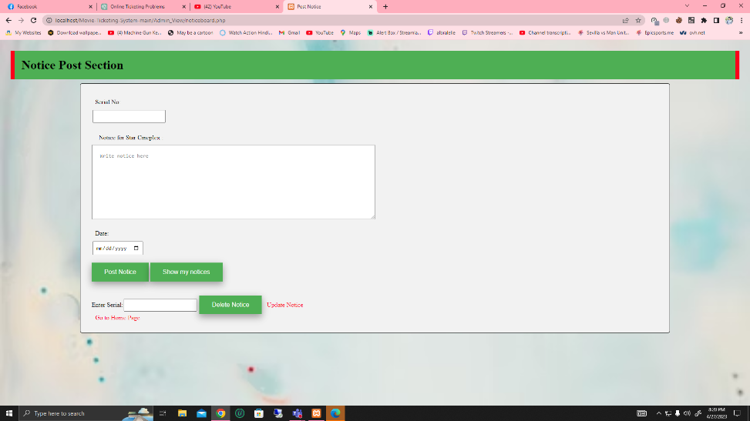

Figure: 4.3(7) Admin Post Notice

|  |  |
| --- | --- |
|  |  |

Figure: 4.3(8) Seller Login Page Figure: 4.3(9) Seller Registration Page

|  |  |
| --- | --- |
|  |  |

Figure: 4.3(10) Seller Home Page Figure: 4.3(11) Seller Workspace

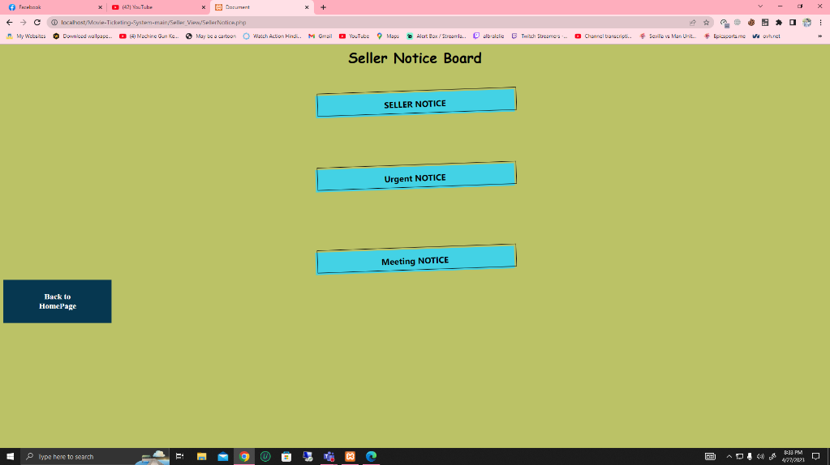

Figure: 4.3(12) Seller Notice Board

|  |  |
| --- | --- |
|  |  |

Figure: 4.3(13) User Login Page Figure: 4.3(14) User Home Page

|  |  |
| --- | --- |
|  |  |

Figure: 4.3(15) User Venue Cheek Figure: 4.3(16) User Booked History

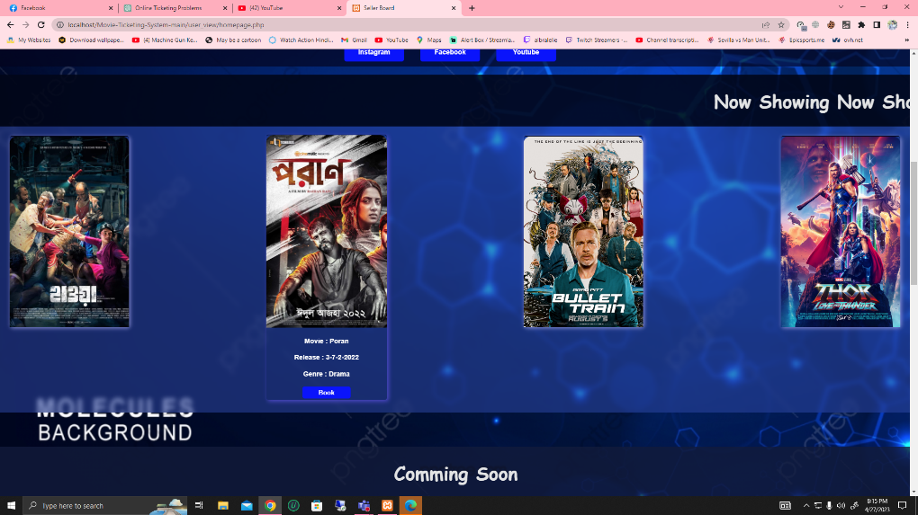

Figure: 4.3(17) User Ticket Booking Page

|  |  |
| --- | --- |
|  |  |

Figure: 4.3(18) Manager Login Page Figure: 4.3(19) Manager Registration Page

|  |  |
| --- | --- |
|  |  |

Figure: 4.3(20) Manager Home Page Figure: 4.3(21) Manager Movie Selection

|  |  |
| --- | --- |
|  |  |

Figure: 4.3(22) Manager Update Hall Figure: 4.3(23) Manager Update Hall List

## Project Requirements

For our project development,

* The number of members needed → 4
* Time needed → 2 months
* 1 month 4 weeks. So, we need 2*4 → 8 weeks
* In 1 week, we get 5 working days
* 1 working days, we get 8 hours
* So, total working hour in per week → (5*8) → 40 hours
* Now total working hour in 8 weeks → (8*40) → 320 hours
* Developers’ salary per hour → 1250 BDT
* Developer’s salary in 320 hours → (1250*320) → 4,00,000 BDT
* Office rent for 3 months → (20000*3) → 60,000 BDT
* Maintenance cost in 1 week (5*1000) → 5,000 BDT
* Maintenance cost in 8 weeks (5,000*8) → 40,000 BDT
* Snacks cost for 1 per in 1 day → 200 BDT
* Snacks cost for 4 per in 1 day → 800 BDT
* Snacks cost for 4 per in 40 day → 32,000 BDT

|  |  |
| --- | --- |
| Expanses | Total Amount (BDT) |
| 4 Developers Salary | 4,00,000 |
| Office rent for 3 months | 60,000 |
| Maintenance Cost | 40,000 |
| Electricity Cost | 4,000 |
| Snacks Cost | 32,000 |
| Miscellaneous Fee | 5,000 |
| Total Cost is | 5,41,000 |
| For Profit 15% of total cost | 81,150 |
| Total Budget is | 6,22,150 |

# FEATURES NOT TO BE TESTED

The following is a list of the areas that will not be specifically addressed. All testing in these areas will be indirect because of other testing efforts. For example:

**Customer Payment Method:** In our web-based application one feature is the customer payment method. In testing time, we did not test this feature.

**Manager Book Ticket:** In our web-based application we already test customer book ticket by customer so that we did not check again with manager book ticket.

**Seller Book Ticket:** In our web-based application we already test admin customer information by admin so that we did not check again with seller book ticket.

# TESTING APPROACH

## Testing Levels

* **Unit Testing:** Test a small software unit at a time. In this test we will test part by part software units. We need to test every single method. It is usually performed by the developer and white box testing is used in it. Main goal of this testing is to isolate written code to test and determine if it works as intended.
* **Integration Testing:** After completing the unit testing, we will start integration testing. Here we will make sure that all the modules in our software are integrated logically. Bottom- up integration is followed in this testing.
* **System Testing:** After completing both tests we will start system testing. In this test we will test all the features in the software. Everything should be done in system testing. Black Box Testing is used to verify all the requirements meet perfectly.
* **Acceptance Testing:** It is the last step of testing. Not only developers but also users can also check this testing. If all the functions work properly the user accepts. Otherwise, the developer needs to fix this problem again. After that, software is ready to release for users.

## Test Tools

We used Selenium IDE for testing cases.

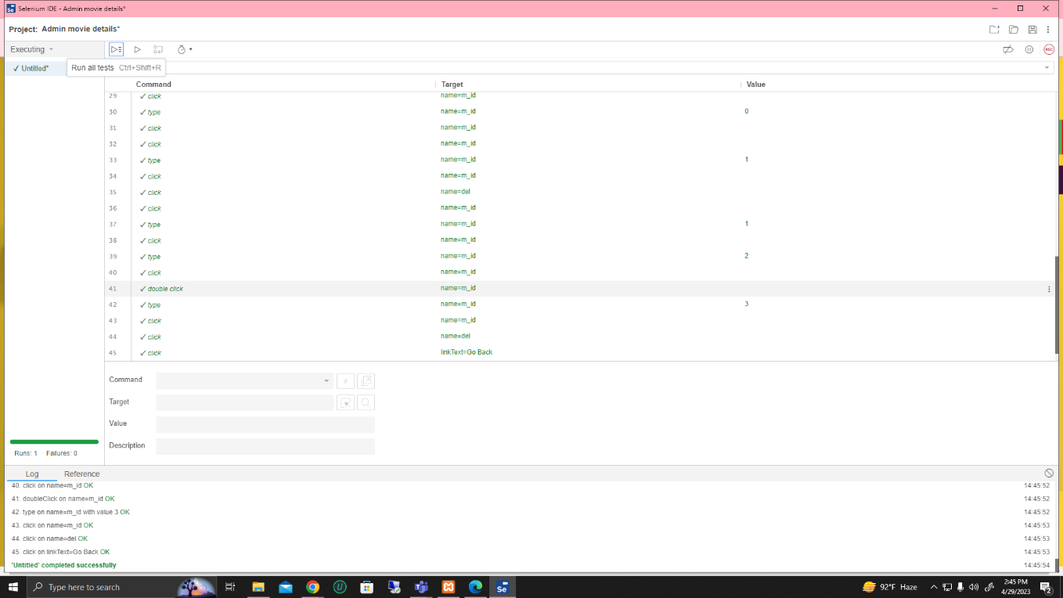

Figure: 6.2(1) admin movie details test completed successfully

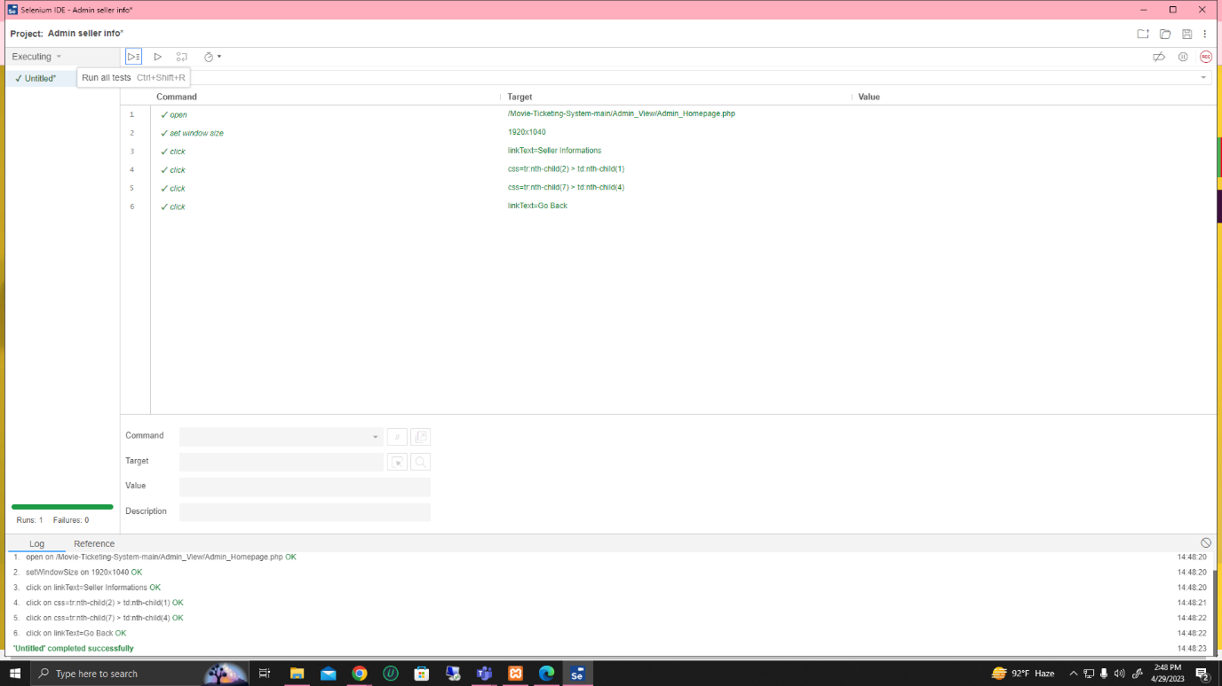

Figure: 6.2(2) admin seller info test completed successfully

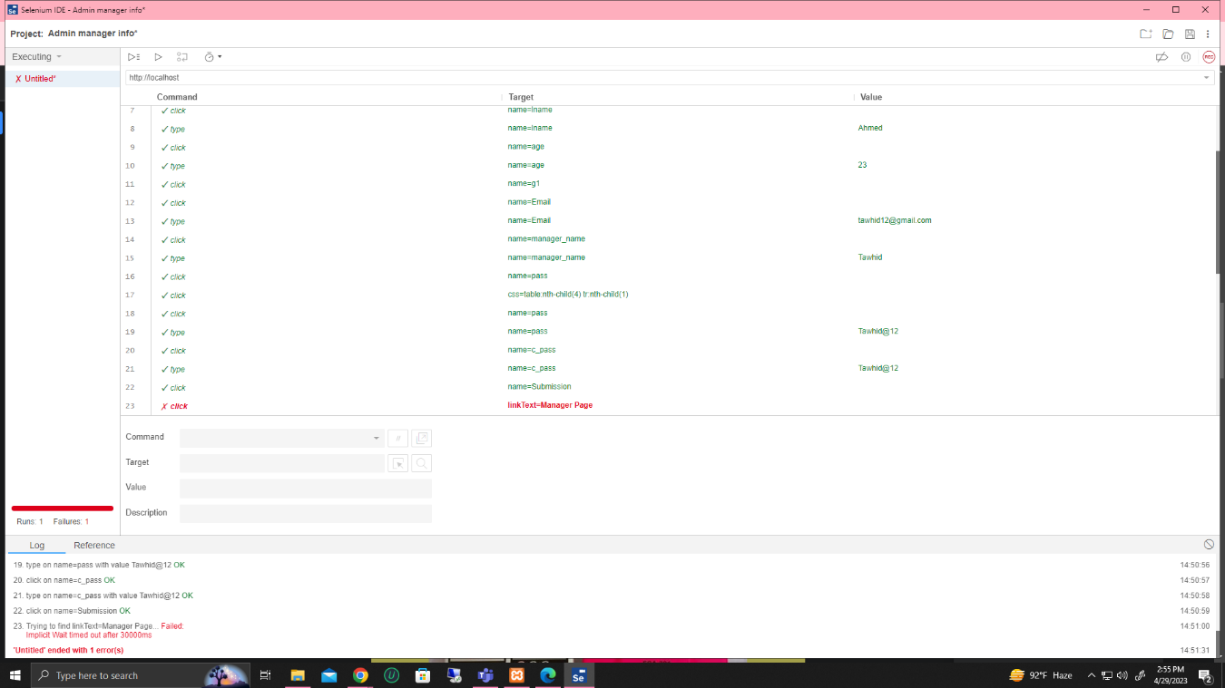

Figure: 6.2(3) admin manager info test failed

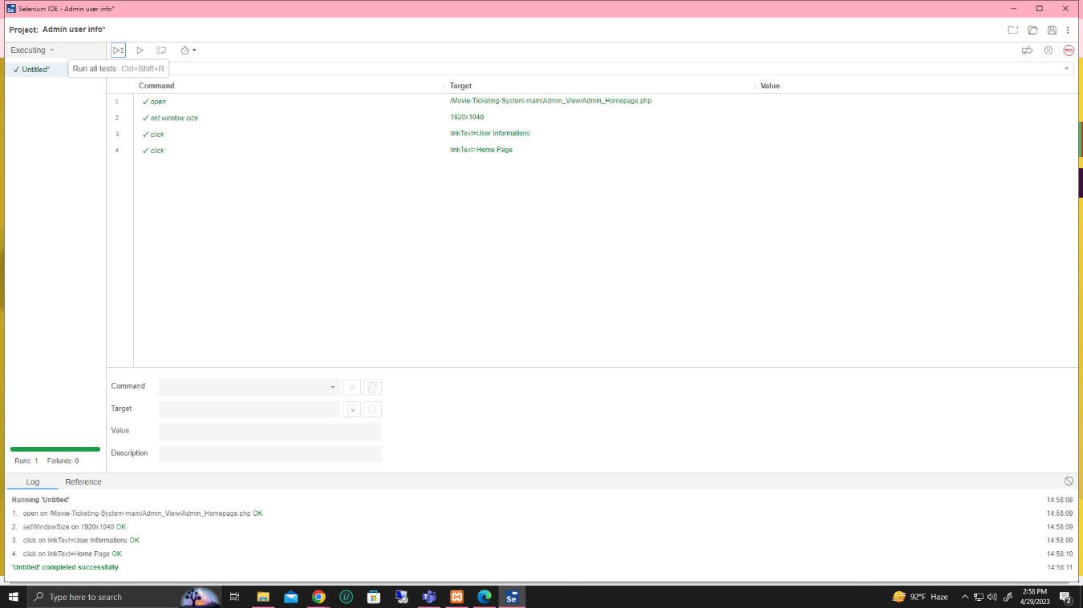

Figure: 6.2(4) admin user info test successfully completed

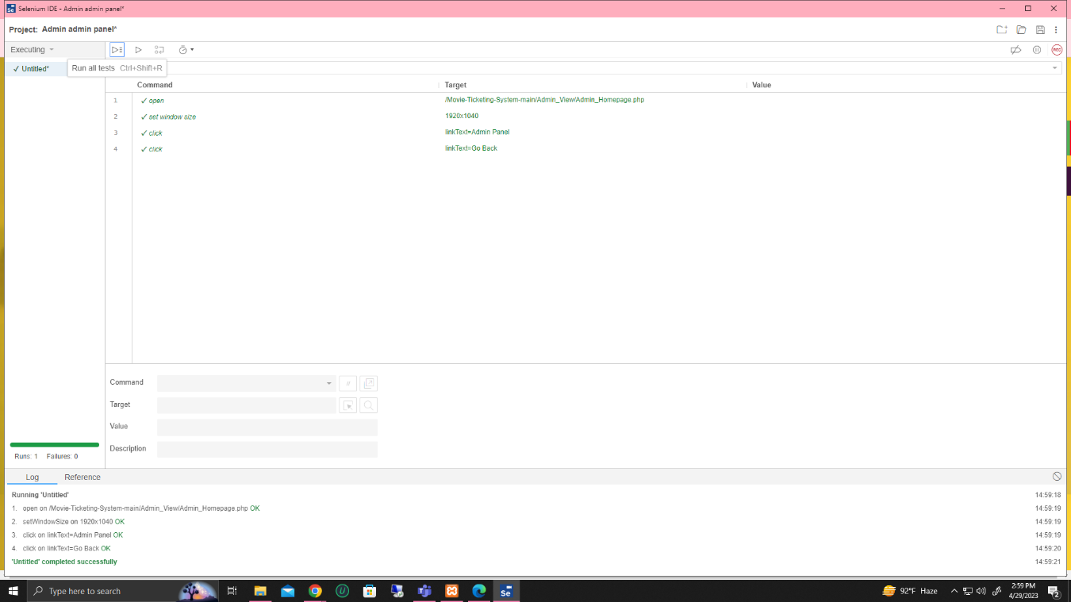

Figure: 6.2(5) admin test admit panel successfully completed

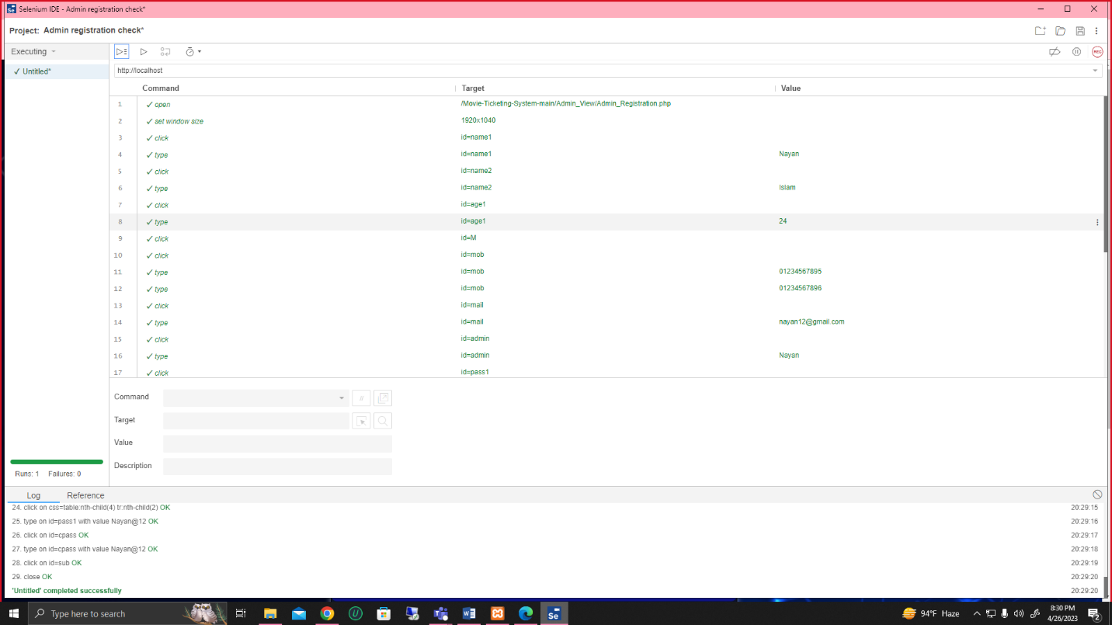

Figure: 6.2(6) admin registration test cheek successfully completed

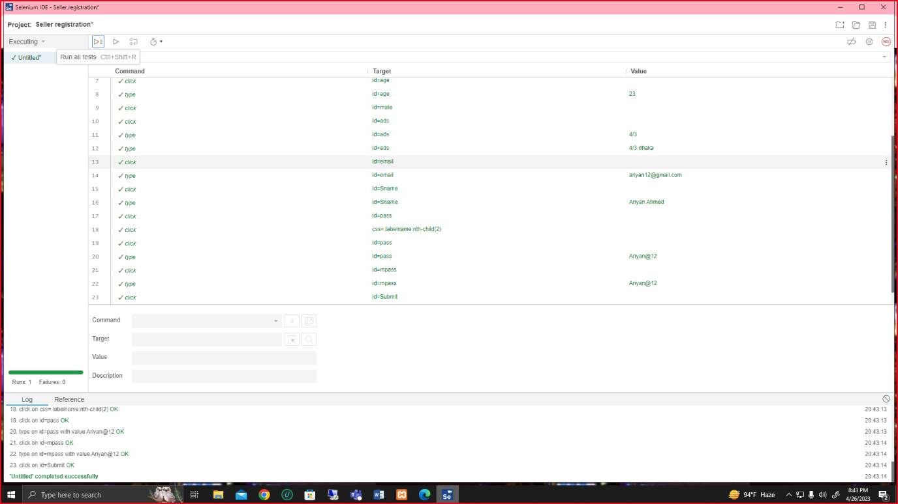

Figure: 6.2(7) seller registration test cheek successfully completed

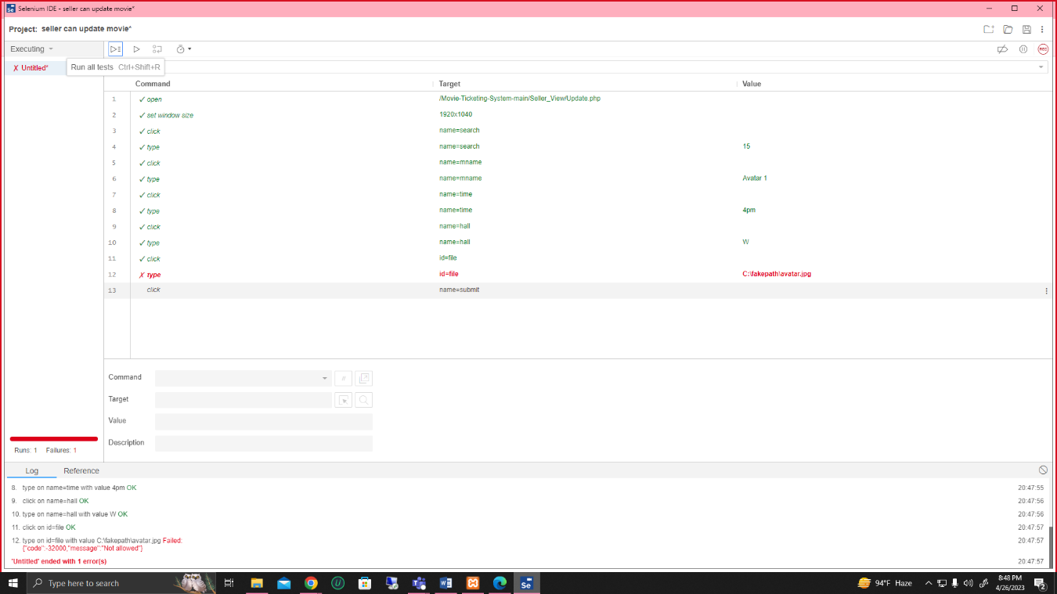

Figure: 6.2(8) seller update movie and hall name test failed

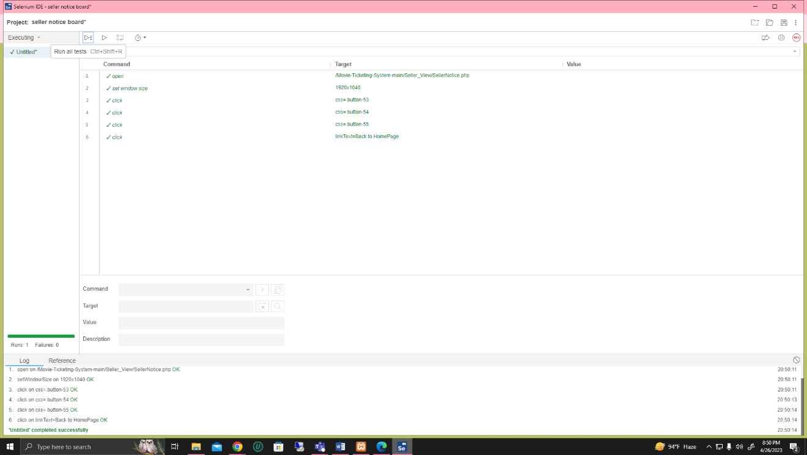

Figure: 6.2(9) seller notice board test successfully completed

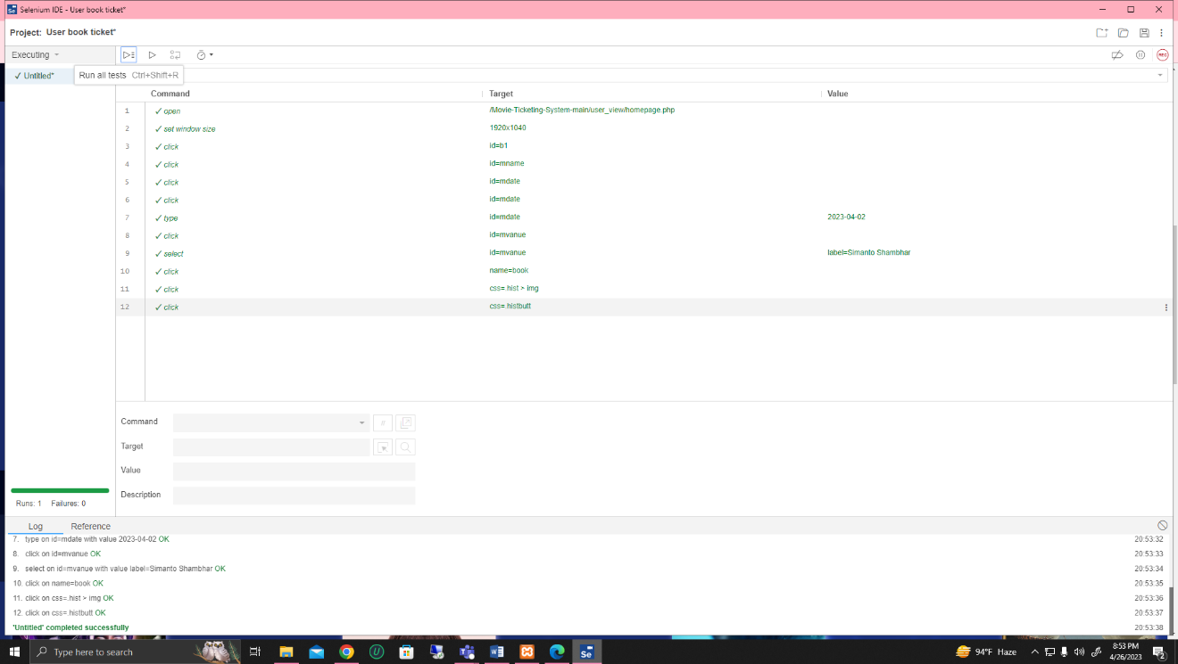

Figure: 6.2(10) user booking ticket test successfully completed

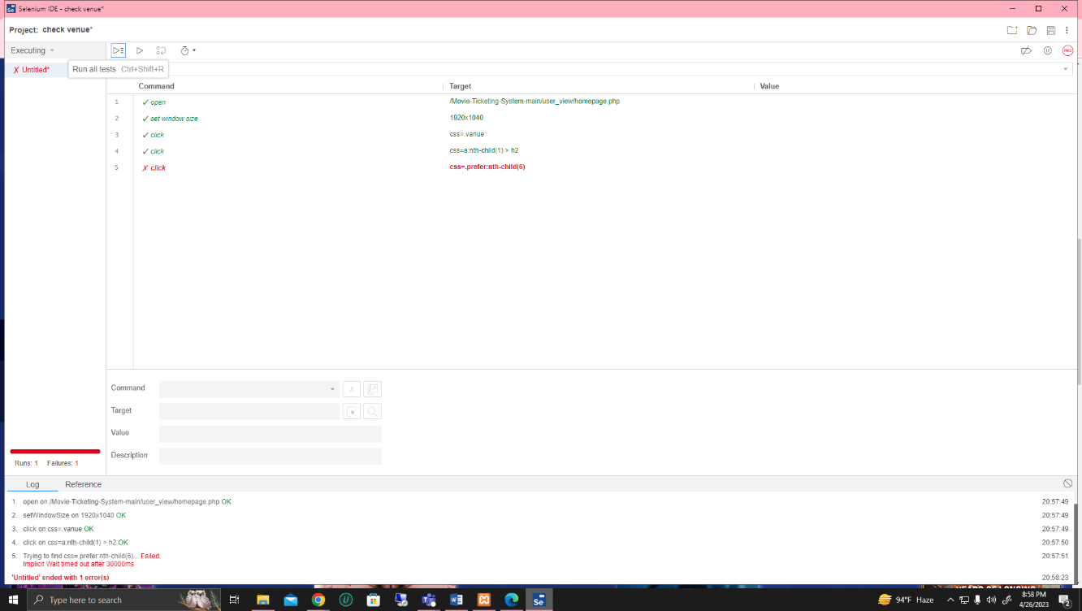

Figure: 6.2(11) user venue cheek test failed

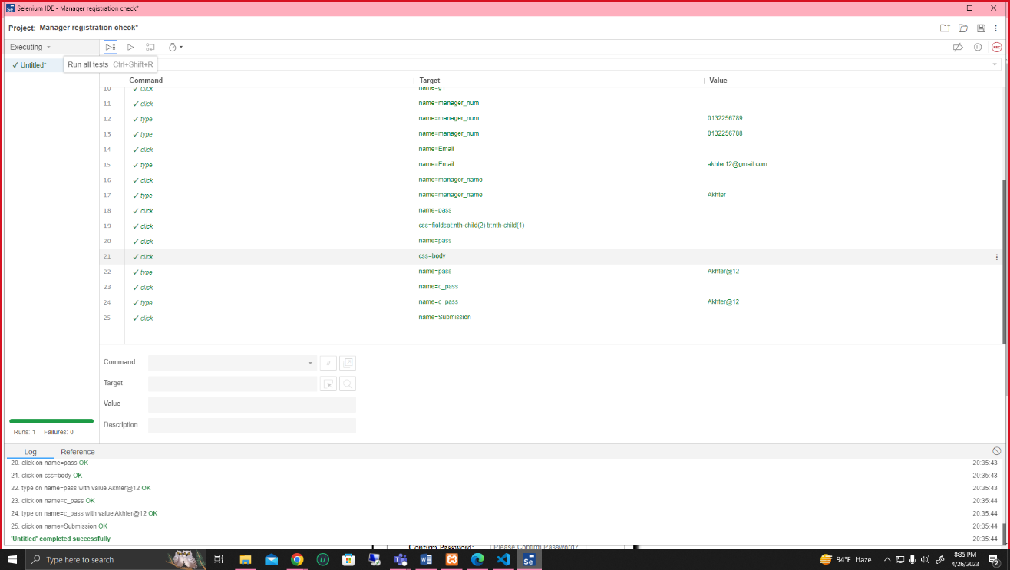

Figure: 6.2(12) manager registration cheek test successfully completed

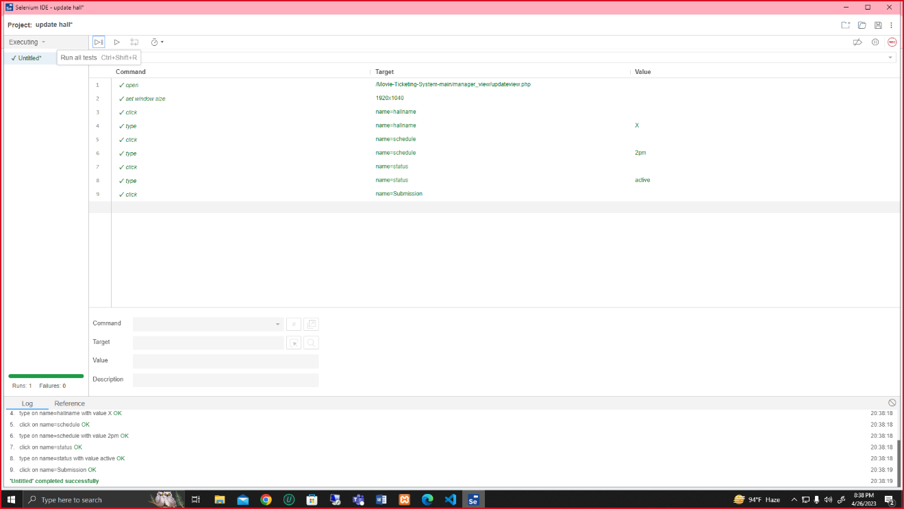

Figure: 6.2(13) manager update hall test successfully completed

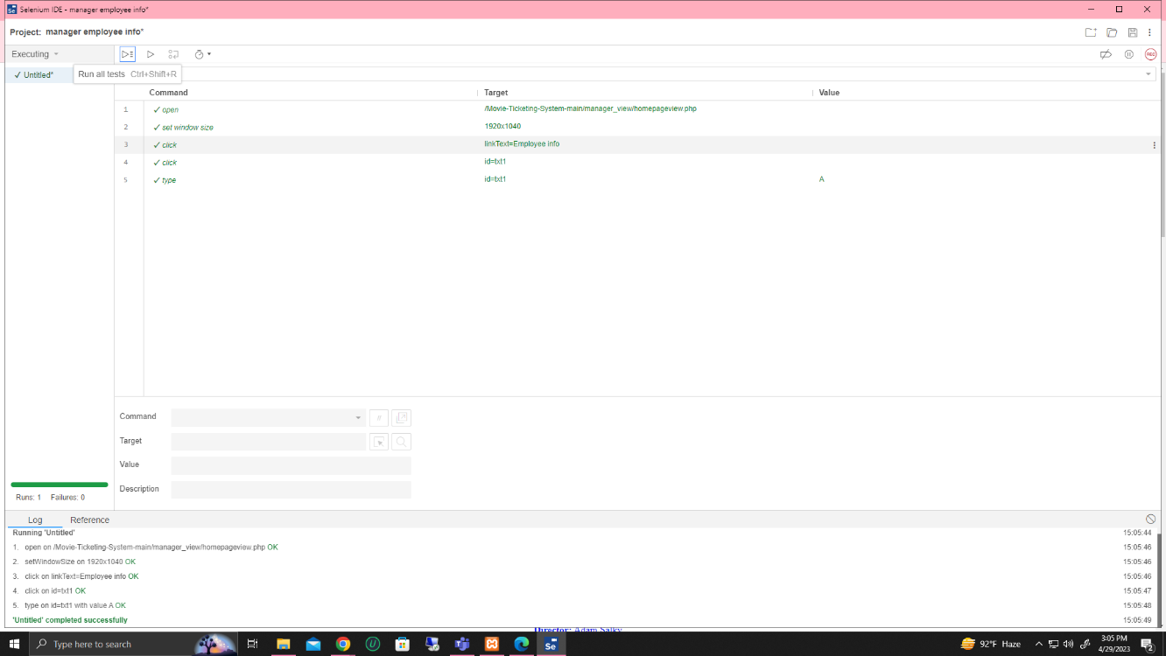

Figure: 6.2(14) manager employee info test successfully completed

## Meetings

To complete a project perfectly work should be distributed to the right person/team. All the members in a team need to understand their work in their selected area. The test team will meet once every week to evaluate progress to date and to identify error trends and problems as early as possible. The test team leader will meet with development and the project manager once every two weeks. These two meetings will be scheduled in different weeks. Additional meetings can be called as required for emergency situations.

# TEST CASES/TEST ITEMS

**7.1 Admin Signup**

|  |  |  |  |  |  |
| --- | --- | --- | --- | --- | --- |
| Project Name: Online Movie Ticketing System | | | Test Designed by: Tanjim Hossain | | |
| Test Case ID: Admin Signup _01 | | | Test Designed date: 30/04/23 | | |
| Test Priority (Low, Medium, High):  High | | | Test Executed by: Tanjim Hossain | | |
| Module Name: Admin Signup Session | | | Test Execution date: 2/05/23 | | |
| Test Title:  Signup with valid username and password | | |  | | |
| Description: Test website admin signup page | | |  | | |
| Precondition (If any):  Admin Cannot use null value in User_Name / Password | | | | | |
| Test Steps | Test Data | Expected Results | | Actual Results | Status (Pass/Fail) |
| 1. Go to the website    2. Click on Admin Button     3.Enter User_Name     4. Enter Password   5.Enter Confirm Password    6. Click submit | User_Name: Tanj  Password: 1234**  Confirm Password: 1234** | Admin should signup into the application | | As expected, | Pass |
| Post Condition: User is validated with database and successfully signup to account. The account session details are stored in the database. | | | | | |

**7.2 Admin Login**

|  |  |  |  |  |  |
| --- | --- | --- | --- | --- | --- |
| Project Name: Online Movie Ticketing System | | | Test Designed by: Tanjim Hossain | | |
| Test Case ID: Admin Login _02 | | | Test Designed date: 30/04/23 | | |
| Test Priority (Low, Medium, High):  High | | | Test Executed by: Tanjim Hossain | | |
| Module Name: Admin Longin Session | | | Test Execution date: 2/05/23 | | |
| Test Title:  Longin with valid username and password | | |  | | |
| Description: Test website admin Login page | | |  | | |
| Precondition (If any): Admin must type valid User_Name / Password which is already stored in database. | | | | | |
| Test Steps | Test Data | Expected Results | | Actual Results | Status (Pass/Fail) |
| 1. Go to the website    2. Click on Admin Button     3.Click on Login Button     4.Enter User_Name     5.Enter Password    6. Click submit | User_Name: Tanj  Password: 1234** | Admin should login into the application | | As expected, | Pass |
| Post Condition: User is validated with database and successfully login to account. The account session details are stored in the database. | | | | | |

**7.3 Admin Can Remove Manager**

|  |  |  |  |  |  |
| --- | --- | --- | --- | --- | --- |
| Project Name: Online Movie Ticketing System | | | Test Designed by: Tanjim Hossain | | |
| Test Case ID: Admin can Remove Manager _03 | | | Test Designed date: 30/04/23 | | |
| Test Priority (Low, Medium, High):  High | | | Test Executed by: Tanjim Hossain | | |
| Module Name: Admin can remove manager session | | | Test Execution date: 2/05/23 | | |
| Test Title:  Remove manager | | |  | | |
| Description: Test website admin can remove manager | | |  | | |
| Precondition (If any):   Admin must have valid ‘username’ and ‘password’ saved in database. | | | | | |
| Test Steps | Test Data | Expected Results | | Actual Results | Status (Pass/Fail) |
| 1. Go to the website  2. Click on Admin Button   3.Click on Login Button  4.Enter User_Name.   5.Enter Password  6. Click submit  7. Successfully login and enter Admin home page.  8.click on manager User List.  9.View all the details.  10.Click on the Delete button.  11.See manager information removed from list | User_Name: Tanj  Password: 1234** | Admin can remove manager into the application | | As expected, | Pass |
| Post Condition: Admin can view any time after login with his valid User_Name & Password. Then easily modify the data also. | | | | | |

7.4 **Admin Can Remove seller**

|  |  |  |  |  |  |
| --- | --- | --- | --- | --- | --- |
| Project Name: Online Movie Ticketing System | | | Test Designed by: Tanjim Hossain | | |
| Test Case ID: Admin can Remove Seller _04 | | | Test Designed date: 30/04/23 | | |
| Test Priority (Low, Medium, High):  High | | | Test Executed by: Tanjim Hossain | | |
| Module Name: Admin can remove seller session | | | Test Execution date: 2/05/23 | | |
| Test Title:  Remove seller | | |  | | |
| Description: Test website admin can remove seller | | |  | | |
| Precondition (If any):   Admin must have valid ‘username’ and ‘password’ saved in database. | | | | | |
| Test Steps | Test Data | Expected Results | | Actual Results | Status (Pass/Fail) |
| 1. Go to the website  2. Click on Admin Button   3.Click on Login Button  4.Enter User_Name.   5.Enter Password  6. Click submit  7. Successfully login and enter Admin home page.  8.click on seller User List.  9.View all the details.  10.Click on the Delete button.  11.See seller information removed from list | User_Name: Tanj  Password: 1234** | Admin can remove seller into the application | | As expected, | Pass |
| Post Condition: Admin can view any time after login with his valid User_Name & Password. Then easily modify the data also. | | | | | |

**7.5 Can delete notice and can update notice**

|  |  |  |  |  |  |
| --- | --- | --- | --- | --- | --- |
| Project Name: Online Movie Ticketing System | | | Test Designed by: Tanjim Hossain | | |
| Test Case ID: Admin can delete notice and can update notice _05 | | | Test Designed date: 30/04/23 | | |
| Test Priority (Low, Medium, High):  High | | | Test Executed by: Tanjim Hossain | | |
| Module Name: Admin can delete notice and can update notice session | | | Test Execution date: 2/05/23 | | |
| Test Title:delete notice and can update notice | | |  | | |
| Description: Test website admin can delete notice and update notice | | |  | | |
| Precondition (If any):   Admin must have valid ‘username’ and ‘password’ saved in database. | | | | | |
| Test Steps | Test Data | Expected Results | | Actual Results | Status (Pass/Fail) |
| 1. Go to the website  2. Click on Admin Button   3.Click on Login Button  4.Enter User_Name.   5.Enter Password  6. Click submit  7. Successfully login and enter Admin home page.  8.click on notice board.  9.View all the notices.  10.select notice.  11. click the delete button.  11.See notice removed from board.  12. click notice board.  13. select notice.  14. click update button.  15.see notice updated from  board. | User_Name: Tanj  Password: 1234** | admin can delete notice and update notice into the application | | As expected, | Pass |
| Post Condition: Admin can view any time after login with his valid User_Name & Password. Then easily modify the data also. | | | | | |

**7.6 Admin Can Remove Movie and Update Movie**

|  |  |  |  |  |  |
| --- | --- | --- | --- | --- | --- |
| Project Name: Online Movie Ticketing System | | | Test Designed by: Tanjim Hossain | | |
| Test Case ID: Admin can delete movie and can update movie _06 | | | Test Designed date: 30/04/23 | | |
| Test Priority (Low, Medium, High):  High | | | Test Executed by: Tanjim Hossain | | |
| Module Name: Admin can delete movie and can update movie session | | | Test Execution date: 2/05/23 | | |
| Test Title:delete movie and can update movie | | |  | | |
| Description: Test website admin can delete movie and update movie | | |  | | |
| Precondition (If any):   Admin must have valid ‘username’ and ‘password’ saved in database. | | | | | |
| Test Steps | Test Data | Expected Results | | Actual Results | Status (Pass/Fail) |
| 1. Go to the website  2. Click on Admin Button   3.Click on Login Button  4.Enter User_Name.   5.Enter Password  6. Click submit  7. Successfully login and enter Admin home page.  8.click on movie list.  9.View all the movies.  10.select movie.  11. click the delete button.  11.See movie removed from list.  12. click movie list.  13. select new movie.  14. click update button.  15.see movie updated from  list. | User_Name: Tanj  Password: 1234** | admin can delete movie and update movie into the application | | As expected, | Pass |
| Post Condition: Admin can view any time after login with his valid User_Name & Password. Then easily modify the data also. | | | | | |

**7.7 Admin Can Reset Password**

|  |  |  |  |  |  |
| --- | --- | --- | --- | --- | --- |
| Project Name: Online Movie Ticketing System | | | Test Designed by: Tanjim Hossain | | |
| Test Case ID: Admin can Reset Password _07 | | | Test Designed date: 30/04/23 | | |
| Test Priority (Low, Medium, High):  High | | | Test Executed by: Tanjim Hossain | | |
| Module Name: Admin can reset password session | | | Test Execution date: 2/05/23 | | |
| Test Title:  Reset Password | | |  | | |
| Description: Test website admin can reset password | | |  | | |
| Precondition (If any):   Admin must have valid ‘username’ and ‘password’ saved in database. | | | | | |
| Test Steps | Test Data | Expected Results | | Actual Results | Status (Pass/Fail) |
| 1. Go to the website  2. Click on Admin Button   3.Click on Login Button  4.Enter User_Name.   5.Enter Password  6. Click submit  7. Successfully login and enter Admin home page.  8.click on forget password  9.Type new password  10.Re-Type new password  11.click the confirm button.  12.Show Changed password. | User_Name: Tanj  Password: 1234** | Admin can reset password to the application | | As expected, | Pass |
| Post Condition: Admin can view any time after login with his valid User_Name & Password. Then easily modify the data also. | | | | | |

**7.8 Admin view all data**

|  |  |  |  |  |  |
| --- | --- | --- | --- | --- | --- |
| Project Name: Online Movie Ticketing System | | | Test Designed by: Tanjim Hossain | | |
| Test Case ID: Admin view all data _08 | | | Test Designed date: 30/04/23 | | |
| Test Priority (Low, Medium, High):  High | | | Test Executed by: Tanjim Hossain | | |
| Module Name: Admin view all data session | | | Test Execution date: 2/05/23 | | |
| Test Title:  View all data | | |  | | |
| Description: Test website admin view all data | | |  | | |
| Precondition (If any):   Admin must have valid ‘username’ and ‘password’ saved in database. | | | | | |
| Test Steps | Test Data | Expected Results | | Actual Results | Status (Pass/Fail) |
| 1. Go to the website  2. Click on Admin Button   3.Click on Login Button  4.Enter User_Name.   5.Enter Password  6. Click submit  7. Successfully login and enter Admin home page.  8.click on manager User List.  9.View all the details.  10.Click on customer user list.  11.View all the details. | User_Name: Tanj  Password: 1234** | Admin can view All information into the application | | As expected, | Pass |
| Post Condition: Admin can view any time after login with his valid User_Name & Password. | | | | | |

**7.9 Seller can cancel the ticket**

|  |  |  |  |  |  |
| --- | --- | --- | --- | --- | --- |
| Project Name: Online Movie Ticketing System | | | Test Designed by: Tanjim Hossain | | |
| Test Case ID: Seller can cancel the ticket _09 | | | Test Designed date: 30/04/23 | | |
| Test Priority (Low, Medium, High):  High | | | Test Executed by: Tanjim Hossain | | |
| Module Name: Seller can cancel the ticket session | | | Test Execution date: 2/05/23 | | |
| Test Title:  Cancel the ticket | | |  | | |
| Description: Test website seller can cancel the ticket | | |  | | |
| Precondition (If any):  Seller must have valid ‘username’ and ‘password’ saved in database | | | | | |
| Test Steps | Test Data | Expected Results | | Actual Results | Status (Pass/Fail) |
| 1. Go to the website  2. Click on Seller Button   3.Click on Login Button  4.Enter User_Name.   5.Enter Password  6. Click submit  7. Successfully login and enter seller home page.  8.click on ticket booking List.  9.View all the booked tickets.  10.Click on ticket.  11.click cancel button.  12. canceled ticket. | User_Name: Tanj  Password: 1234** | Admin can view All information into the application | | As expected, | Pass |
| Post Condition: Seller can view any time after login with his valid User_Name & Password. | | | | | |

**7.10 Seller Logout**

|  |  |  |  |  |  |
| --- | --- | --- | --- | --- | --- |
| Project Name: Online Movie Ticketing System | | | Test Designed by: Tanjim Hossain | | |
| Test Case ID: Seller Logout _10 | | | Test Designed date: 30/04/23 | | |
| Test Priority (Low, Medium, High):  High | | | Test Executed by: Tanjim Hossain | | |
| Module Name: Seller Logout Session | | | Test Execution date: 2/05/23 | | |
| Test Title:  Seller Logout | | |  | | |
| Description: Test website Seller Logout page | | |  | | |
| Precondition (If any):   Seller must have valid ‘username’ and ‘password’ saved in database | | | | | |
| Test Steps | Test Data | Expected Results | | Actual Results | Status (Pass/Fail) |
| 1. Go to the website    2. Click on Admin Button     3.Click on Login Button     4.Enter User_Name     5.Enter Password    6.  Click submit    7. After this come to the Seller home page.    8. Click on the logout button.    9.successfully logout and come to website home page. | User_Name: Tanj  Password: 1234** | Seller logout from the application | | As expected, | Pass |
| Post Condition:   Seller is validated with database and successfully login to account and then after completing his task can log out from the website. | | | | | |

**7.11 manager Can add or remove customer**

|  |  |  |  |  |  |
| --- | --- | --- | --- | --- | --- |
| Test Case ID: Manager can add or remove customer_11 | | | Test Designed date: 30/04/23 | | |
| Test Priority (Low, Medium, High):  High | | | Test Executed by: Tanjim Hossain | | |
| Module Name: Manager can add or remove customer session | | | Test Execution date: 2/05/23 | | |
| Test Title: add or remove customer | | |  | | |
| Description: Test website Manager can add or remove customers. | | |  | | |
| Precondition (If any):    Manager must have valid ‘username’ and ‘password’ saved in database. | | | | | |
| Test Steps | Test Data | Expected Results | | Actual Results | Status (Pass/Fail) |
| 1. Go to the website  2. Click on manager Button   3.Click on Login Button  4.Enter User_Name.   5.Enter Password  6. Click submit  7. Successfully login and enter manager home page.  8.click on customer list.  9.View all the customers.  10.select customer.  11. click remove button.  11.See customer removed from list.  12. Again Click customer list.  13. select add customer.  14. click update button.  15.see customer updated from  list. | User_Name: Tanj  Password: 1234** | manager can remove customer and add customer into the application | | As expected, | Pass |
| Post Condition: Manager can view any time after login with his valid User_Name & Password. Then easily modify the customer list. | | | | | |

# ITEM PASS/FAIL CRITERIA

After testing the test cases, we can say that 100% testing is impossible. Here we have tested 14 test cases. From this we can see that 11 test cases were tested successfully and the rest of the 3 cases failed. After checking the problem, we can say that there were some database issues. At last, we can measure that 82.70% of test cases were successful and 17.30% of test cases were failed.

# TEST DELIVERABLES

* Test plan document
* Test design standard
* Test case document
* Test procedures
* Test logs
* Test execution report
* Bug report
* Test closure report
* Release notes

# STAFFING AND TRAINING NEEDS

For completing this project, we need a Project Manager, Programmer & Test Engineer.

**Project Manager:** In this project we will approve all the test plans. He is responsible for the planning, executing and completion of this project. He decided about all the budgets, working tools and other necessary staff are needed for the complete project. At least three years of experience is needed to become e project manager.

**Programmer:** To create a perfect project programmers need to be very sincere about their responsibilities. Programmer can design code, implement code, modify code, etc. Programmer also need at least three years of working experience in the IT industry. Programmers also need to know about different programming languages, and it can be different in different companies as their working requirements.

**Test Engineer:** Test engineer checks all the programs which were written by programmers. They work on a system to ensure that clients get a high-quality product. They also need to know the basic idea about programming because when they are trying to manual test, they might need to check everything but for dynamic it is different.

# RESPONSIBILITIES

|  |  |  |
| --- | --- | --- |
| Name | Project Role | Responsibilities |
| MD TAWHID MIRZA | Project Manager | 1. Control entire project 2. Providing test environment 3. Witnessing all the test performance 4. Checking all the test cases result |
| MD. HAFIZUR RAHMAN | Programmer | 1. Implementing Program 2. Providing the test items with transmittal reports 3. Ensuring all the part connected properly 4. Checking the test result |
| 1. TAUSIFUR RAHMAN 2. TANJIM HOSSAIN | Test Engineer | 1. Designing custom test procedures 2. Executing all the test cases about test planning 3. Prepare report on test activities 4. Checking the test result |

# TESTING SCHEDULE

Time has been allocated within the project plan for the following testing activities. The specific dates and times for each activity are defined in the project plan timeline. The people required for each process are detailed in the project timeline and plan as well. Schedule are written on Microsoft excel to trace report and future working purpose.

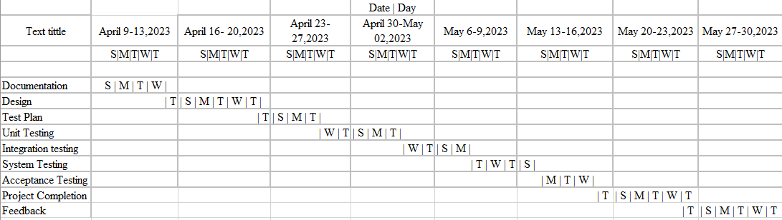

# PLANNING RISKS AND CONTINGENCIES

* One open position exists in the Reassigned Sales administration staff. There may be delays in getting staff members to review all required documents and take part in the Acceptance test process due to this staff shortage. As a result, the appropriate dates for acceptance testing and reviews will be missed by client staff. There will be no attempt to circumvent any aspect of the testing and review procedures.

# APROVALS

|  |  |
| --- | --- |
| Project Sponsor | MD. HAFIZUR RAHMAN |
| Development Management | MD TAWHID MIRZA |
| EDI Project Manager | TAUSIFUR RAHMAN |
| RS Test Manager | TANJIM HOSSAIN |
| ES Development Team Manager | MD TAWHID MIRZA |